OCAR PLATFORM
Feature Requirements Documentation
Auto Rickshaw In-City Rental
Version 1.0
September 2026

Introduction
This document sets out the functional requirements for a new addition to the Ocar platform: Auto Rickshaw In-City Rental.
It describes what changes at the data, backend, and frontend layers, how the feature behaves across the full ride lifecycle, its edge cases, and which parts of the existing system it reuses versus what is newly built.

1. Overview
Auto rickshaw is added as a new vehicle category, alongside the existing hatchback, sedan, SUV, luxury, and van categories. It is scoped to in-city travel only, and is booked exclusively as a rental: the rider selects a fixed package, a bundled amount of time and distance for one price, rather than paying a per-kilometre one-way fare. Distance or time driven beyond the package's allowance is billed at that package's own overage rate once the trip ends.
The category launches with multiple package tiers and is treated as fully isolated from every other category: an auto rickshaw driver is never offered a sedan booking as a fallback, and vice versa, since the two serve different rider needs and are not interchangeable.
Supporting this touches four areas: the pricing and category data model, the fare estimation and booking logic, the trip completion and fare settlement logic, and the rider and admin facing screens that display and configure it. Document requirements for driver onboarding are unchanged: an auto rickshaw is registered through the same checklist already used for every other category, with no new document type required.
Pricing follows the same package structure already used by the existing rental categories for both in-city and outstation bookings: a duration, a distance allowance, a package fare, and two overage rates, one per kilometre and one per minute, charged only on distance and time driven past the allowance. Auto rickshaw launches with multiple selectable tiers built on this structure rather than a single fixed package. The exact tiers and rates are configured separately.

2. Data Layer Changes
Two migrations support this feature. The first introduces the category itself and its pricing:
Table | Change
vehicle_categories | One new row: auto_rickshaw, maximum 3 passengers.
rate_cards | One new row, for the rental ride type only. No one_way or round_trip row is created for this category; booking those ride types against it is rejected by design, since auto rickshaw is package-priced, in-city travel only.
stop_charges | One new row, required by the schema for every category regardless of how often multi-stop rentals are used for this vehicle type.
rental_packages | Multiple new rows, one per launch package tier, each bundling a time and distance allowance for a fixed fare with its own overage rate.
vehicle_brands / vehicle_models | Five manufacturers (Bajaj, Piaggio, Atul, TVS, Mahindra) and their model lineups seeded, so a driver registering an auto rickshaw has real options in the make and model dropdown rather than an empty list.
category_fallback_rules | No rows added, in either direction. This is what makes the category fully isolated: the ride-assignment logic never substitutes an auto rickshaw for another category's booking, or the reverse.
A second migration adds four nullable columns to fare_snapshots: the package's overage rate per kilometre, its overage rate per minute, its distance allowance, and its time allowance. The reasoning behind this migration is set out in Section 3.2.

3. Backend Changes
Backend work for this feature is not limited to registering a new category in existing lookups. Two changes close real gaps in how rental rides are priced and settled today, and both extend to every existing rental category, not to auto rickshaw alone. Auto rickshaw is what makes fixing them necessary now; the fix itself improves billing accuracy across the platform's whole rental product.

3.1 Fare Estimation
The fare-estimate endpoint, already called whenever a rider views package options before booking, is extended to return the selected package's overage rate and allowance alongside its price, so those terms can be captured at booking time in the next step.

3.2 Booking
When a rental ride is created, the returned package terms are written onto that ride's own fare record. From this point on, the ride's own record, not the live rental_packages row, is the source of truth for what this rider agreed to pay for overage.
This matters because rental packages, unlike rate cards, are not versioned: an admin edit to a package's pricing updates that package's row directly rather than creating a new one. Without freezing the terms a rider was quoted at the moment of booking, a package price change made while a trip is already in progress could silently alter what that rider is charged at settlement. That is a billing-integrity gap that exists for every rental category today, not one introduced by auto rickshaw, and it is closed as part of this build.

3.3 Trip Completion and Fare Settlement
At the end of a trip, the platform already reconstructs the actual distance driven from the GPS pings recorded throughout the ride, rather than trusting the driver app's own on-device estimate, for outstation round trips. This same reconciliation is extended to cover rental rides generally, auto rickshaw included. The billed distance and duration for overage purposes now come from the recorded GPS trail whenever enough location data was captured during the trip, with the same safeguard already in place elsewhere: a sanity ceiling that discards a GPS trail implying an implausible distance, falling back to the client-reported estimate and flagging the ride for review.
This closes a second gap that exists for every rental category today, where final billing relies on an on-device estimate rather than measured movement. Auto rickshaw cannot launch safely on that older, estimate-based settlement path, which is why the fix ships as part of this build, but every existing rental category is billed more accurately from the same change.
Overage is then computed against the package's frozen allowance, at its frozen overage rate, and added to the package fare to produce the final amount shown to the rider.

3.4 Validation and Error Handling
A booking request for this category against the one_way or round_trip ride type is rejected at the API layer with a specific, category-aware error, surfaced to the rider before they can submit rather than left to fail on a missing rate card row.

4. Frontend Changes

4.1 Rider App
The in-city rental screen moves from its current horizontal layout to a vertical one. Vehicle categories are listed top to bottom instead of side to side, and selecting a category expands its package tiers directly beside it, rather than sending the rider to a separate step to compare tiers. A rider can see their chosen vehicle type and its available packages in the same glance, without losing their place on the screen.
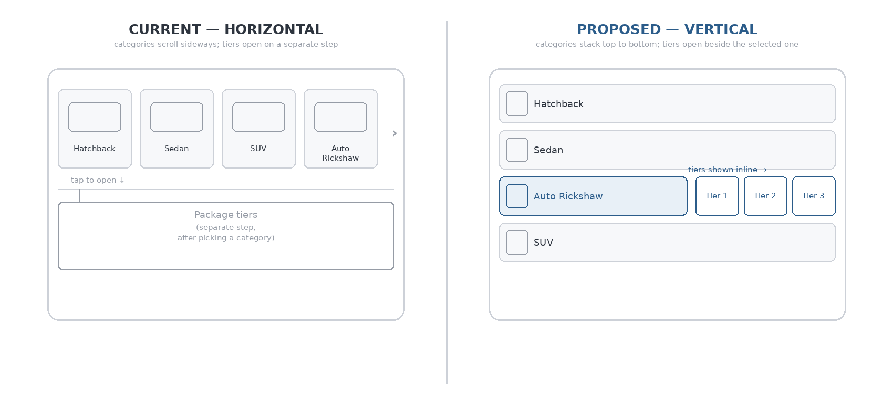
Figure 1. Rental screen layout, current versus proposed (illustrative).
As part of this change, a new vehicle silhouette is added for auto rickshaw's three-wheeler shape, so the category reads as visually distinct from the four-wheeled options rather than falling back to a generic car icon.
A related fix is required on the separate one-way and round-trip booking screen, which is not part of this redesign. That screen renders every available vehicle category and fetches a live fare for each one; every category so far has supported all three ride types, so this has never been an issue. Auto rickshaw is the first category that does not support one-way or round-trip travel, and without a fix it would appear there as a selectable card with no valid fare behind it. The screen now only displays categories for which a fare was actually returned.

4.2 Admin Portal
Auto rickshaw is added to the category ordering used by the rate-card configuration screen and its rental-packages tab, so its pricing and package tiers are visible and editable there through the existing rate-card and package management interface, without a new screen.
The driver-management page is also split into two tabs, Car and Auto Rickshaw, instead of one mixed list. This is a frontend and a backend change together: the driver-listing endpoint gains a category filter so each tab is served its own scoped list, and this composes with the existing per-city filter already on that page, so an admin can filter auto rickshaw drivers by city exactly as they already can for car drivers.
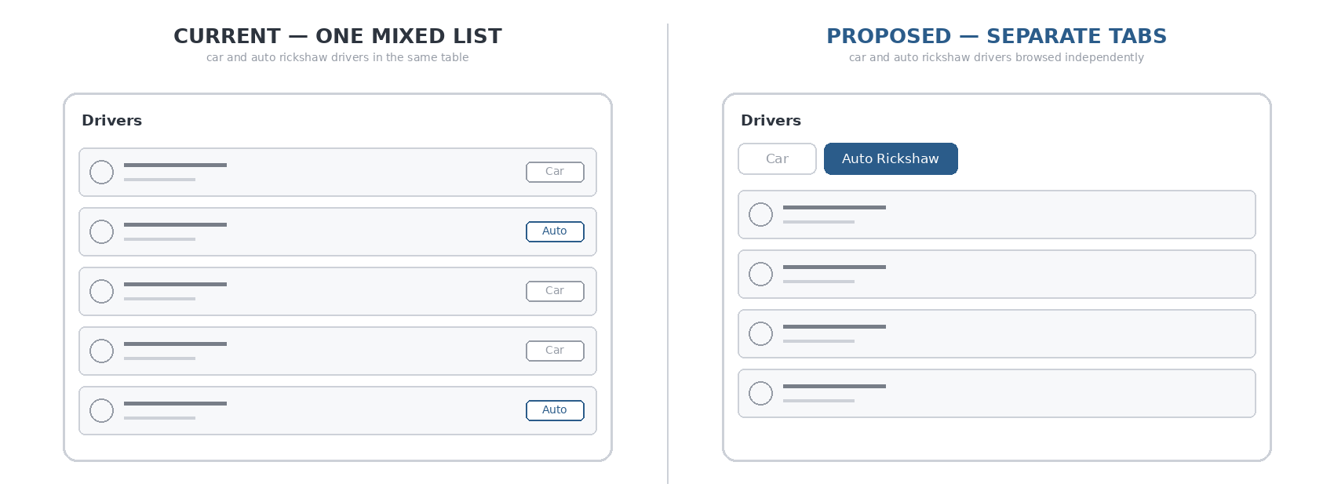
Figure 2. Driver-management page, current versus proposed (illustrative).

4.3 Driver App
No change is required. The vehicle-category selector shown during driver onboarding is already populated from the categories list returned by the backend, so auto rickshaw and its seeded brand and model options appear there automatically once the category exists in the data layer. Document requirements are unchanged: an auto rickshaw is registered through the same checklist used for every other category today.

5. Edge Cases and Operational Notes
- A fare-estimate request for one_way or round_trip against this category is rejected server side even if a client briefly shows it from a stale cached category list, so the booking screen can never be led into a doomed booking attempt.
- Multi-stop rentals: the stop_charges row exists so the schema supports it, but whether multi-stop is exposed in the rider UI for auto rickshaw rentals is a presentation choice, not a backend limitation, and can be toggled without further backend work.

6. Ride Lifecycle
1. Rider opens the redesigned rental page — existing flow, new category
Selects Auto Rickshaw from the vertical category list and one of its package tiers, shown beside the selection.
2. Fare estimate returned — existing endpoint, extended
Package fare, plus its overage rate and allowance in kilometres and minutes.
3. Booking created — existing step, terms now frozen
The package's overage rate and allowance are frozen onto this ride's fare record, so a later admin edit to the package cannot change what this rider was quoted.
4. Driver accepts, arrives, ride starts by OTP — existing
Unchanged from every existing ride type.
5. Driver app pings GPS location — existing
Roughly every three seconds for the duration of the trip.
6. Trip ends by OTP — existing
Rider and driver confirm at the same code exchange used elsewhere.
7. Server reconstructs actual distance and duration — new for rental rides
From the recorded GPS trail, not the phone's own estimate. Falls back to the phone's estimate and flags the ride for review if the trail is too short or missing.
8. Distance and time beyond the package allowance — new for rental rides
Billed at the frozen overage rate.
9. Final fare is written and shown to the rider — existing pattern, new inputs
Package fare, plus overage, if any.

7. Components Touched
Layer | Change
Database | One migration for category, rate card, stop charges, package tiers, and brand/model seed data; a second migration adding four columns to the fare-snapshot table.
Pricing service | Fare-estimate response extended to carry a package's overage terms, applying to every rental category, not only auto rickshaw.
Rides service | Booking persists the frozen package terms; trip completion gains a rental-specific reconciliation branch against GPS-tracked distance and duration, with its own fallback and review-flagging path, applying to every rental category, not only auto rickshaw.
Rider app | Rental screen rebuilt from horizontal to vertical, with package tiers shown beside the selected category; new vehicle icon; category-list fix on the one-way / round-trip screen.
Admin portal | Category ordering updated in the rate-card screen and its rental-packages tab; driver-management page split into Car and Auto Rickshaw tabs, backed by a new category filter on the driver-listing endpoint.
Driver app | No change; onboarding is data-driven from the categories already added in the database layer, and document requirements are unchanged.
Test coverage | New unit tests for the rental trip-completion reconciliation branch, covering the GPS-backed path and the estimate fallback path.

